**-- Customers Table**

**CREATE OR REPLACE TABLE silverlayer.Customers (**

**CustomerID INT64,**

**Name STRING,**

**Email STRING,**

**Address STRING**

**);**

**-- Products Table**

**CREATE OR REPLACE TABLE silverlayer.Products (**

**ProductID INT64,**

**Name STRING,**

**Category STRING,**

**Price NUMERIC**

**);**

**-- OnlineTransactions Table**

**CREATE OR REPLACE TABLE silverlayer.OnlineTransactions (**

**OrderID INT64,**

**CustomerID INT64,**

**ProductID INT64,**

**DateTime DATETIME,**

**PaymentMethod STRING,**

**Amount NUMERIC,**

**Status STRING**

**);**

**-- Stores Table**

**CREATE OR REPLACE TABLE silverlayer.Stores (**

**StoreID INT64,**

**Location STRING,**

**Manager STRING,**

**OpenHours STRING**

**);**

**-- InStoreTransactions Table**

**CREATE OR REPLACE TABLE silverlayer.InStoreTransactions (**

**TransactionID INT64,**

**CustomerID INT64,**

**StoreID INT64,**

**DateTime DATETIME,**

**Amount NUMERIC,**

**PaymentMethod STRING**

**);**

**-- Agents Table**

**CREATE OR REPLACE TABLE silverlayer.Agents (**

**AgentID INT64,**

**Name STRING,**

**Department STRING,**

**Shift STRING**

**);**

**-- CustomerServiceInteractions Table**

**CREATE OR REPLACE TABLE silverlayer.CustomerServiceInteractions (**

**InteractionID INT64,**

**CustomerID INT64,**

**DateTime DATETIME,**

**AgentID INT64,**

**IssueType STRING,**

**ResolutionStatus STRING**

**);**

**-- LoyaltyAccounts Table**

**CREATE OR REPLACE TABLE silverlayer.LoyaltyAccounts (**

**LoyaltyID INT64,**

**CustomerID INT64,**

**PointsEarned INT64,**

**TierLevel STRING,**

**JoinDate DATE**

**);**

**-- LoyaltyTransactions Table**

**CREATE OR REPLACE TABLE silverlayer.LoyaltyTransactions (**

**LoyaltyID INT64,**

**DateTime DATETIME,**

**PointsChange INT64,**

**Reason STRING**

**);Created four tables to load the cleaned data:**

**Writes to the another silver layer**

**Job submitted:**

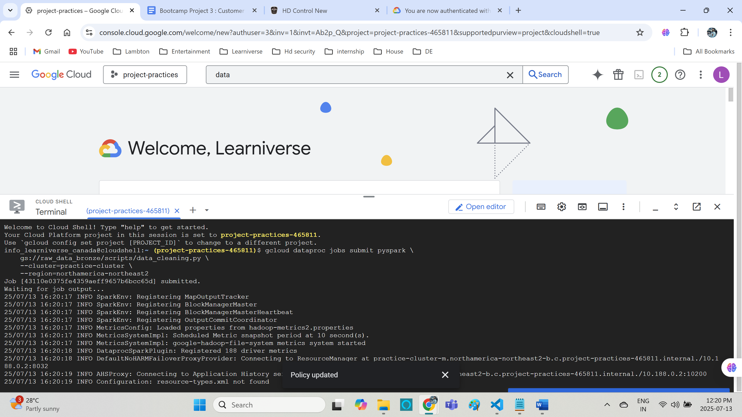

**Loading to bigquery:**

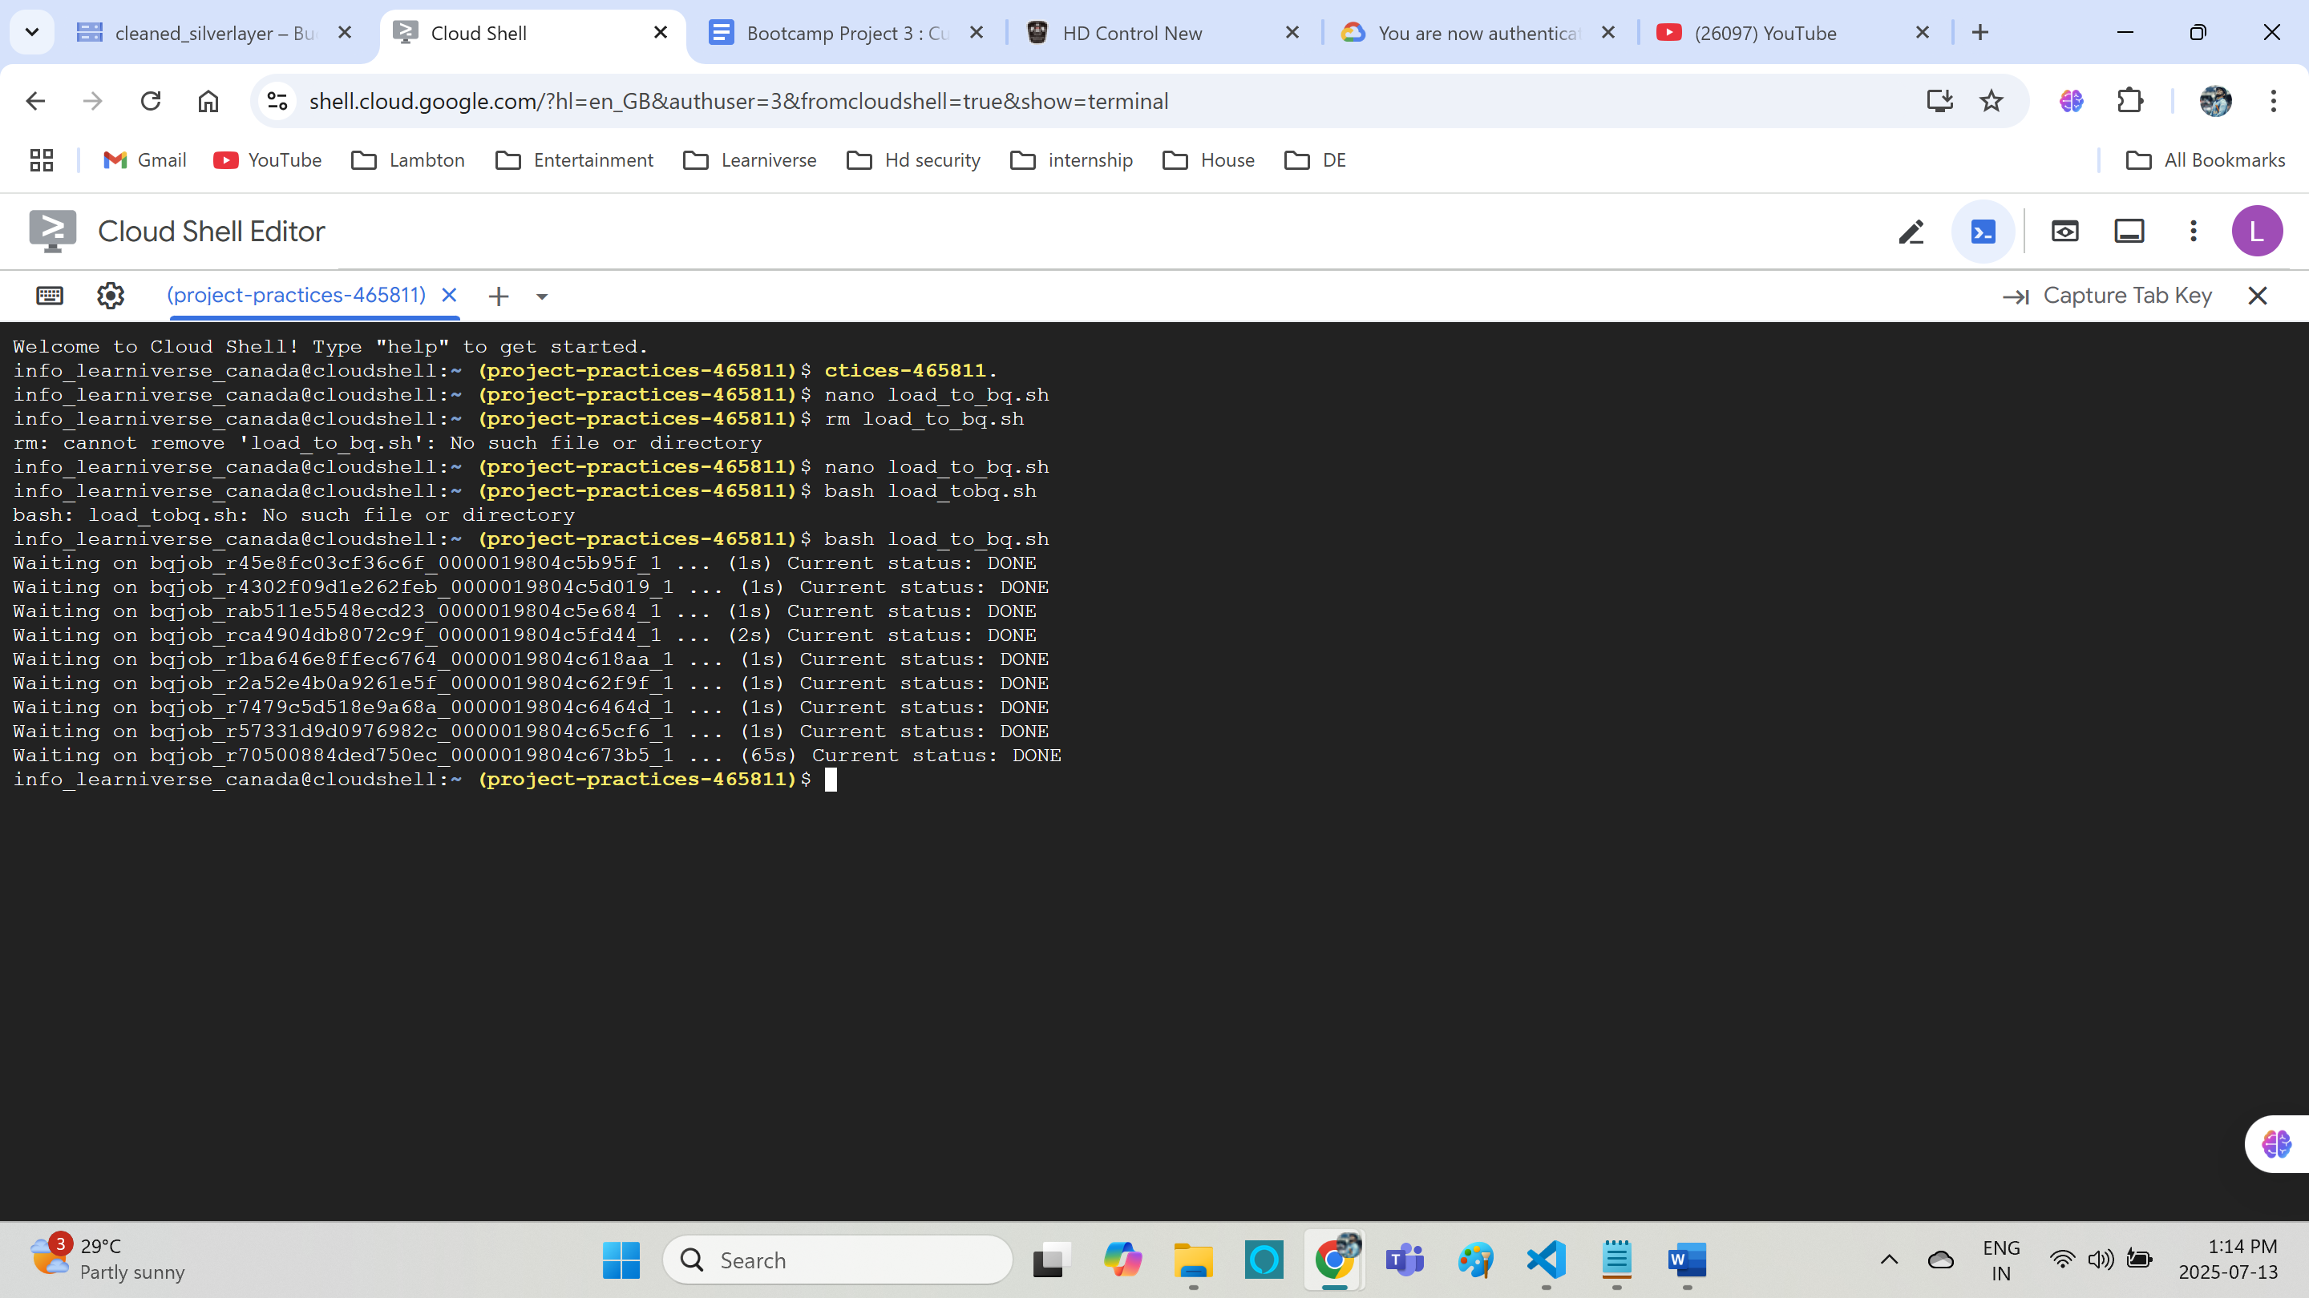

**Loaded everything:**

**Aggregated data:**

**gcloud dataproc jobs submit pyspark \**

**gs://raw_data_bronze/scripts/goldlayer_aggregation.py \**

**--cluster=practice-cluster \**

**--region=northamerica-northeast2 \**

**--properties=spark.pyspark.python=python3**

